1. Introduction

RvtUnit is an example of how to achieve Unit Testing within Revit. By running the NUnit runner inside Revit, we can unit test code which relies on the Revit API, without having to wrap the entire Revit API.

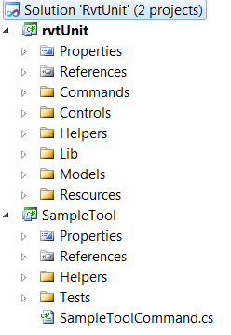The solution contains two projects:

The RvtUnit project is the main project that runs the unit tests.

The SampleTool project shows an example of a Revit IExternalCommand which includes unit tests.

* 1. RvtUnit project
* Designed using the MVVM pattern
* References a custom build of NUnit which has been modified to load DLL’s from a byte array, rather than form disk
* Allows user to select a directory of dll’s, and it will then load them and present a dialog which lets the user run some or all tests
  1. SampleTool project
* Contains an example of an IExternalCOmmand which includes some classes which are unit tested
* The ‘production code’ and the ‘test code’ are compiled into the same dll
* Contains standard unit tests, and Specflow tests
* The Specflow test also use Moq, although a custom build of both Moq and Castle.Core are required, as the objects must be properly disposed at the end of the test.